**IFTTT**

First, you must create an account on IFTTT, For the sake of simplicity, we will continue with Google as we need to control devices with Google Assistant.

Then, click on Create.

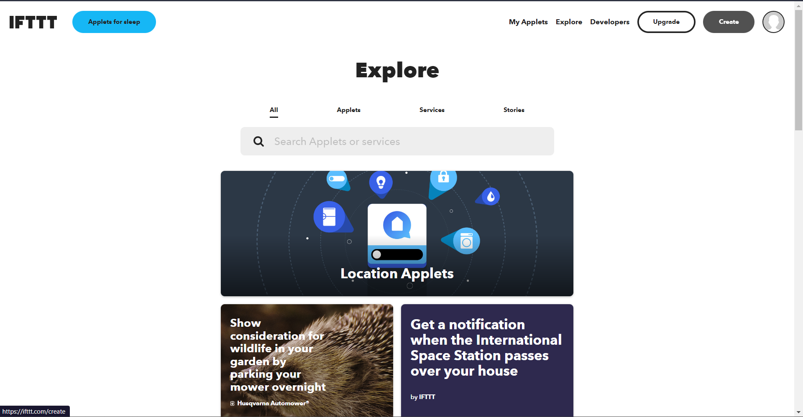



We have to create an applet. In the “***If This”*** Section, click on ADD and search for Google Assistant.

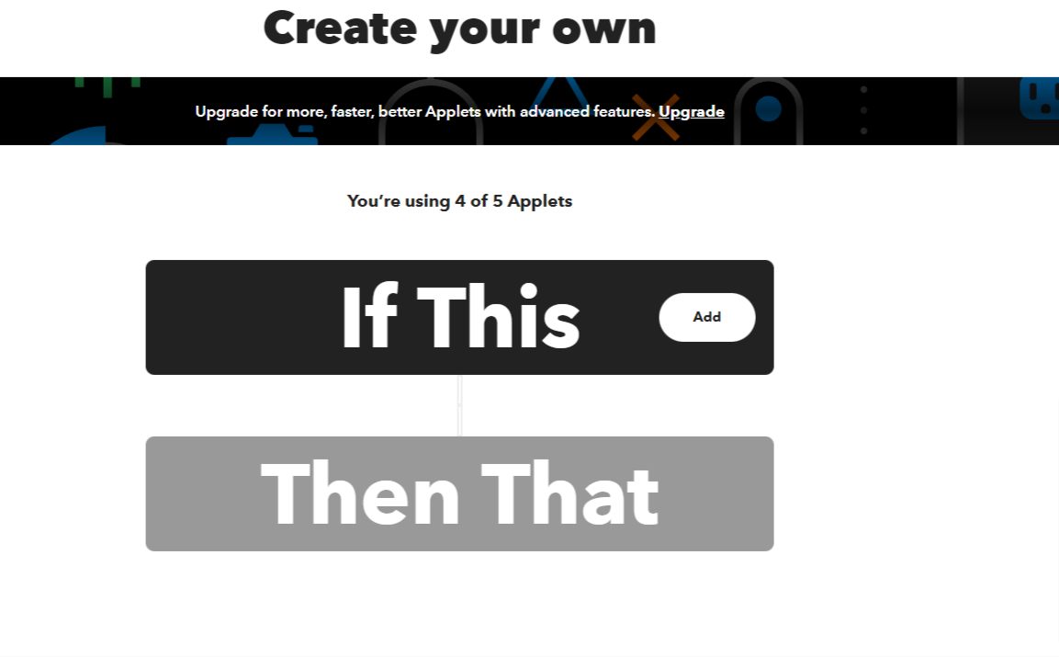

Choose Say a simple phrase from the options.



In What do you want to say, enter- Ok Google Turn on LED 1 (or whatever you want to trigger), and you should add two other ways of saying that like Okay Google Turn the First LED on… etc.

Now in What do you want the Assistant to say in response - enter Okay, Turning the LED 1 On.

Leave if English Language is already selected or select it and click on Create Trigger.

Now, click on the **+** icon, in ***“Then That”*** section of the Action Service Search for webhooks and select it.

Click Connect Then, click on make a web request and complete the action fields like the Screen shots attached. URL consists of the following: the IP Address of blynk cloud followed by your auth token then / then update then / then the GPIO pin at which device is connected in the NodeMCU.

<https://188.166.206.43/your-auth-token/update/pin-number>.

Pin number- D0, D1….

Select Method as – PUT

Content type- application/json

Leave the additional headers empty and in Body, enter - ["1"]

Similarly, follow steps to turn on LED light by creating another Applet accordingly and just change the body to- [“0”]

**SETTING UP BLYNK APP**

Log in to the Blynk app using your Facebook account. Make sure you have an email connected to the Facebook account.

Now Create a new project, give it a name, and choose device as Node MCU, Connection type – Wi-Fi, Click create. An Auth Token will be sent to your E-mail connected with the Facebook account. You will use this Auth token to connect your NodeMCU with the blynk and in IFTTT.

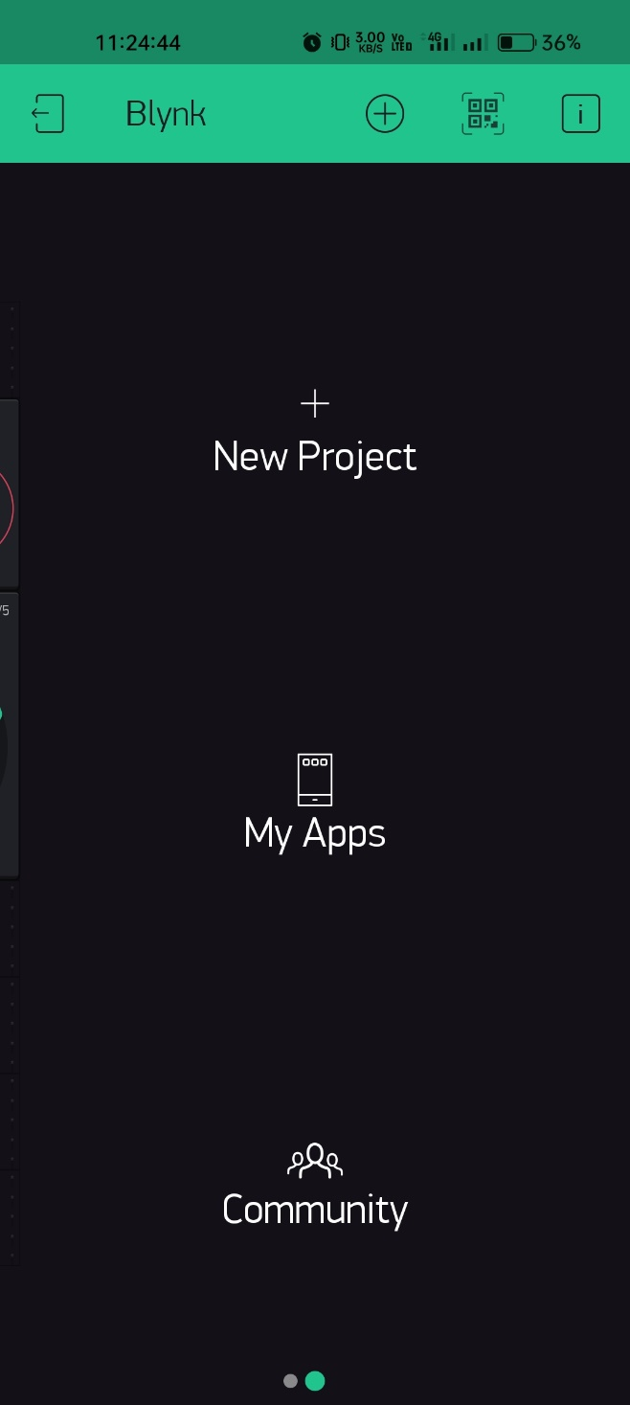



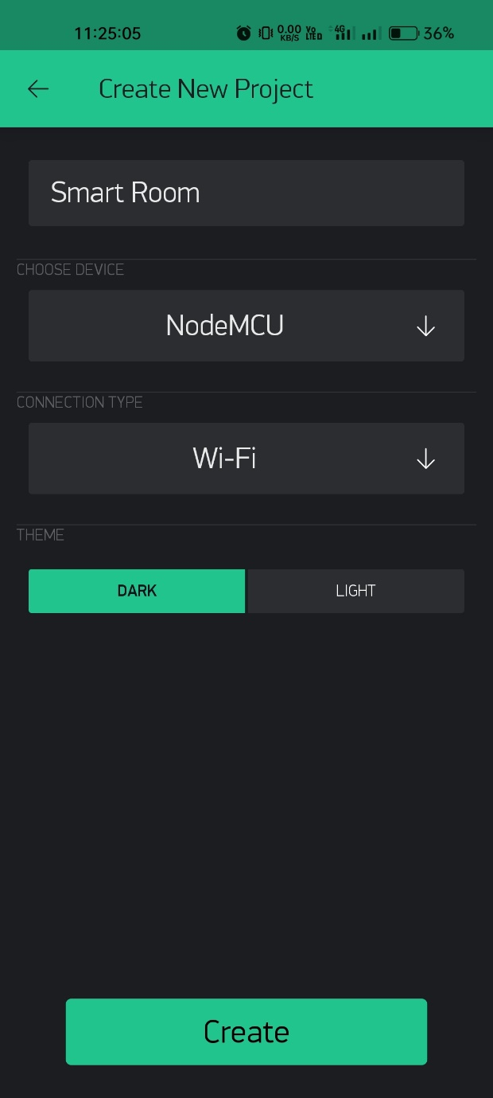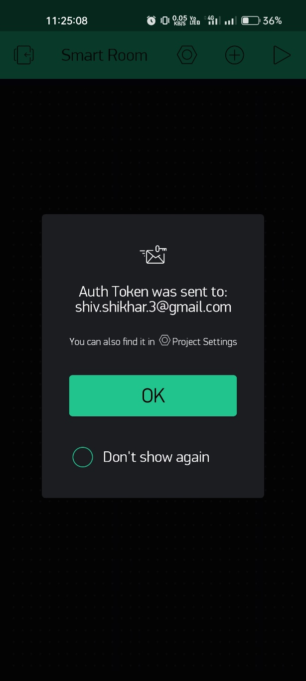



After this, Add Button, and give it a name.

Set OUTPUT to Let’s say D3, and 0___|-----1

Mode – Switch and you are done.

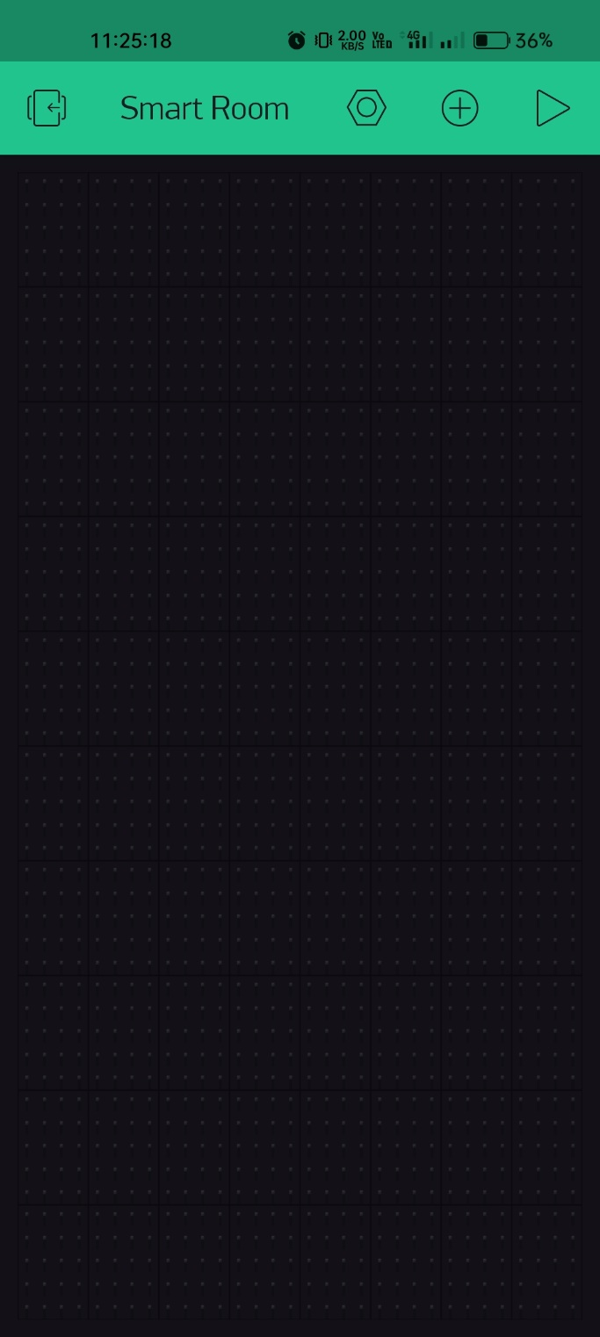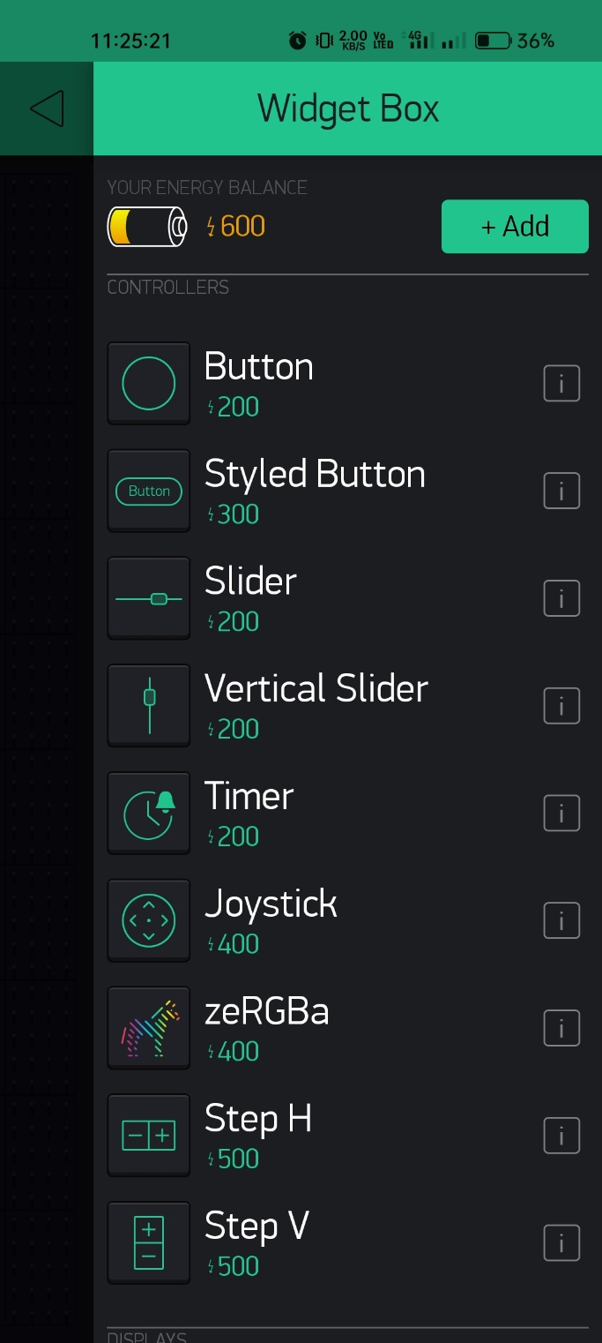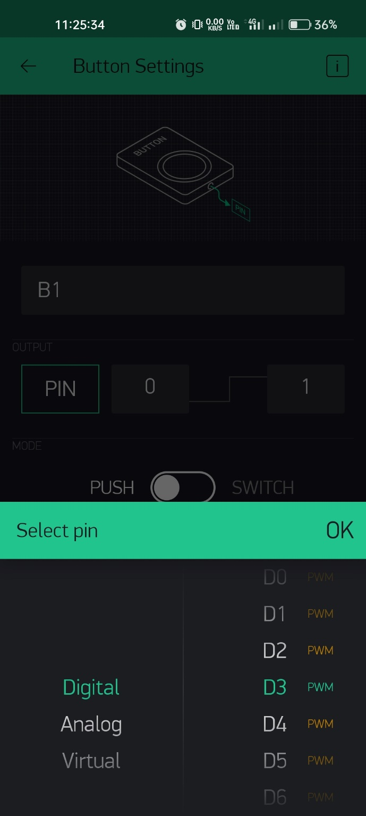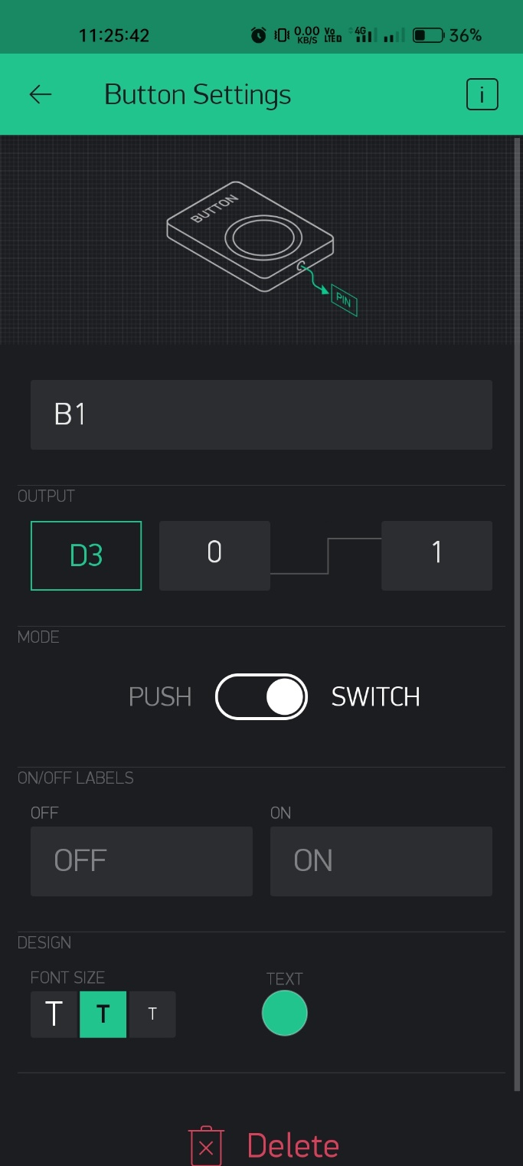



You can add multiple Buttons to control various devices with NodeMCU.